**Experiment No. 8**

**Title: Image Processing Basics using Skimage**

**Batch: Roll No: Experiment No.:8**

**Aim:** Image processing basics using skimage

**Resources needed:** Any Python IDE

**Theory:**

Images form a significant part of data in current times. Image Processing is the process of analysing and manipulating a digital image primarily aimed at improving its quality or for extracting some information from it which could then be put to some use. Images are stored as rectangular arrays of hundreds, thousands, or millions of discrete “picture elements,” otherwise known as pixels. Each pixel can be thought of as a single square point of colored light. Images are just numpy arrays. Broadly there are three layers to images Red, Blue and Green. Images can be gray scale and color images. The color of each pixel can be represented as an RGB triplet of numbers. Image processing tasks include:

* Displaying images
* Basic manipulations like cropping, flipping, rotating etc
* Image Segmentation: task of labeling the pixels of objects of interest in an image.
* Classification and feature extractions Image restoration Image recognition
* Morphometrics: counting the number of objects in an image, analyzing the size of the objects, or analyzing the shape of the object
* Colorimetrics: analyzing the color of objects in an image.
* Image Segmentation is essentially the process of partitioning a digital image into multiple segments to simplify and/or change the representation of an image into something that is more meaningful and easier to analyze. Thresholding is a type of image segmentation, where we change the pixels of an image to make the image easier to analyze.

**Skimage:**

Scikit-image, or skimage, is an open source Python package designed for image preprocessing. It includes algorithms for segmentation, geometric transformations, color space manipulation, analysis, filtering, morphology, feature detection, and more. It is designed to interoperate with the Python numerical and scientific libraries NumPy and SciPy. The important submodules of skimage includes:

* Color • data
* draw
* exposure
* feature
* filters
* io
* segmentation
* transform
* viewer

These API provides various functions to achieve image processing tasks.

**Activities:**

1. Read an image and perform the following:

1. Change image format and apply rescaling, resizing
2. Slice off a specific part of the image and replace sliced portion with other fill.
3. Mask your photo(students are expected to use their own photo)
4. Obtain the three layers of the input image.
5. Blur the image by applying gaussian filter.(define which region of image you are going to apply functions )
6. Perform edge detection

**Result:** (script and output)

**Questions:**

1. What is thresholding? Discuss the purpose of thresholding.

Thresholding is a type of image segmentation, where we change the pixels of an image to make the image easier to analyze. In thresholding, we convert an image from color or grayscale into a binary image, i.e., one that is simply black and white.

1. What are the different image segmentation techniques?

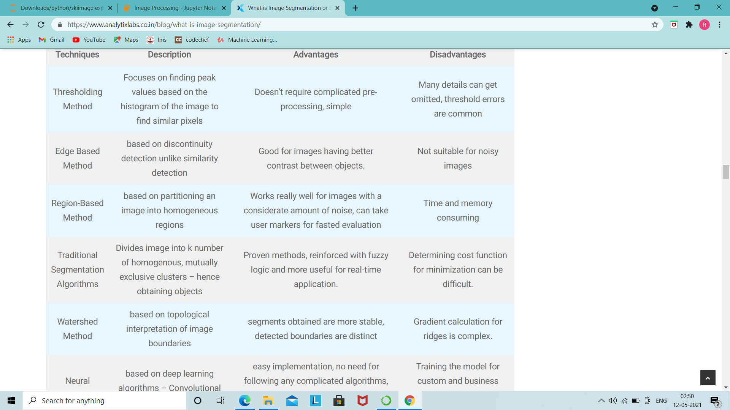

1. What are the different API Libraries available with skimage and write down the purposes?

**Outcomes:**

**Conclusion:** (Conclusion to be based on the objectives and outcomes achieved)

**References:**

1. <https://scikit-image.org/docs/dev/api/api.html>
2. <https://scikit-image.org/>